Overview

This teacher guide is intended to help instructors navigate the set-up and execution of the PTC laboratory protocol. For your convenience, the student protocol has been annotated to include helpful text and optional stopping points with storage conditions, in red. Additional resources for PCR, gel loading, and sequencing can be found at the end of this document.

The teacher guide includes:
- Pre-PTC Laboratory Prep Work
- Annotated PTC Student Manual
- Sequencing Guide
- Teacher Resource: Optional Pre-Laboratory Vocab Review
- Teacher Resource: What is Chelex®?
- Teacher Resource: What is PCR?
  - Guidelines to creating your own PCR-book analogy
- Teacher Resource: Why do we use the PTC reverse primer for sequencing?
- Teacher Resource: Template Sign-Up Sheet for Gel Loading

Teacher Pre-Laboratory Prep Work

- PCR Primer Master Mix
  - You will receive a tube of TAS2R38 (PTC) Primers, which is a mixture of both forward and reverse primers. You will also receive a tube of Standard Master Mix, which may or may not include loading dye. If it does, you may still want to add additional loading dye in part IV step 1 (page 11 in the student manual). You will need to combine these two reagents to make the TAS2R38 Primer Master Mix used in part II, step 1. Each PCR reaction needs the following:
    - 10µL of TAS2R38 Primer
    - 12.5µL of Standard Master Mix
  - We suggest calculating enough for your number of students plus 5 extra reactions for a class of 25.For example, if you are running this lab with 25 students, you would do the following below. You can also prepare reagents for groups of 4 students with 1 extra reaction per group .Label MM on the microcentrifuge tube.

Reagent | Per 1 Student | Per 25 Students | Per 4 students
TAS2R38 Primer | 10µL | 30 X 10µL = 300µL | 6X10 µL=60 µL
30 X 12.5µL of Standard Master Mix | 12.5µL | 30 X 12.5µL = 375µL | 6 X 12.5µL = 75µL
Total | 22.5µL | 675µL | 135 µL

  - In this example, you will pipette 300µL of the TAS2R38 Primers into a new tube. Add 375µL of Standard Master Mix to this tube and pipette up and down to thoroughly mix. Aliquot 22.5µL of this mixture into clean, clear 0.2mL PCR tubes. One tube will be needed for one student. Put on ice in adapter tubes.
  - You can prepare this TAS2R38 Primer Master Mix up to one hour before use.
- Gel loading
  - Prepare gels before part IV. First, prepare 1X Sodium Borate Buffer. This is the same buffer for labs 1.2 and 4A. A 20X stock is provided in your kit. Dilute with deionize water. Make sure you add the appropriate amount of SyberSafe® to your molten agarose/buffer mix with a ratio of 1 part SyberSafe to 10,000 part 1X Sodium Borate Buffer. For example, if your gel tray takes 30mL of this molten agarose/buffer mix, you must add µL of SyberSafe®. For 120 mL of molten agarose, add 12µL SyberSafe®. Remember to mix thoroughly before pouring into your gel tray. Once poured, cover or keep gels out of light until ready to use.
  - You will need one lane per student, one lane of undigested control, and one lane for ladder in each gel.
    - It is up to you whether you allow students to assign themselves or you pre-assign each student to a gel and a lane before students load samples in part IV step 3 (keep track of this list). We have included a sign-up template at the end of this document.
  - Before students load their samples, ensure that you have loaded 10µL of 100bp ladder into the first lane and 20µL of your undigested control in the second lane.

- Chelex Preparation:
- Obtain a 5mL tube of Chelex beads (labeled X) . Pipet 100uL of beads to 0.2mL green PCR tube for each student. Re-suspend beads by pipetting them gently in and out of the pipettor repeatedly between samples.

- 5x Orange G loading dye Preparation: Label LD on microcentrifuge tube
- 12µL per group of 4 students (2uL per student)

- DNA (100bp) ladder: Label M on microcentrifuge tube
- 12µL per gel set up (10uL per gel)
- The teacher may decide to load the ladder in which case it may not be necessary to aliquot.

- HaeIII: Label HaeIII on the microcentrifuge tube
- 12 µL per group (2µL per student)

Annotated Student Manual

Overview

In this laboratory you will explore the connection between your genetics (genotype) and your observed characteristics (phenotype) using taste perception. During a subsequent activity, you will be given an opportunity to taste the compound phenylthiocarbamide (PTC). Upon tasting PTC you will experience one of these three phenotypic reactions: a strong bitter taste, a mild bitter taste, or nothing at all.

The population studies conducted by chemist Arthur L. Fox in the 1930s revealed that the ability to taste PTC is an inherited dominant trait that varies in the human population and influences how we taste PTC. The gene that encodes for the PTC taste receptor, TAS2R38, was identified in 2003. Taste receptors are found on the surface of some of the cells on our tongue and we know today that TAS2R38 encodes for one of the thirty taste receptors that allow detection of bitter-tasting compounds.
Metabolizing our foods begins with breaking them down as we chew. Chemical compounds within the foods will either bind or not bind to taste receptors on the cells of our tongue. If a compound binds to a receptor, this results in activation of the receptor, in which a signal is transmitted to our brains, allowing us to perceive taste.
The TAS2R38 gene has a dominant and a recessive version (allele). Each allele encodes a different version of the PTC taste receptor, and differences in perception of taste are based on which alleles an individual carries. The goal of this laboratory is to determine your genotype using multiple molecular biology techniques. These steps are outlined in Figure 1 (page 2) and described in Table 1 (page 3).
First, you will use Polymerase Chain Reaction (PCR) to amplify (make many copies of) a short region of the TAS2R38 gene. Figure 3 (page 7) outlines the steps of PCR. In order to differentiate between the TAS2R38 alleles, the amplified PCR product will be digested (cut) with the restriction enzyme HaeIII. Restriction enzymes cut at specific DNA sequences, termed recognition sequences. The HaeIII recognition sequence will allow us to distinguish the single-nucleotide polymorphism (SNP) that differentiates the PCR products of the dominant and recessive TAS2R38 alleles. The PCR product of the dominant allele will be cut by the enzyme, while the PCR product of the recessive allele will not, as shown in Figure 1 (page 2). This means that differently sized fragments will be produced for homozygous dominant, homozygous recessive, and heterozygous individuals. Therefore, after the restriction digest with HaeIII, you will use gel electrophoresis to visualize your resulting fragments in order to conclude your genotype.

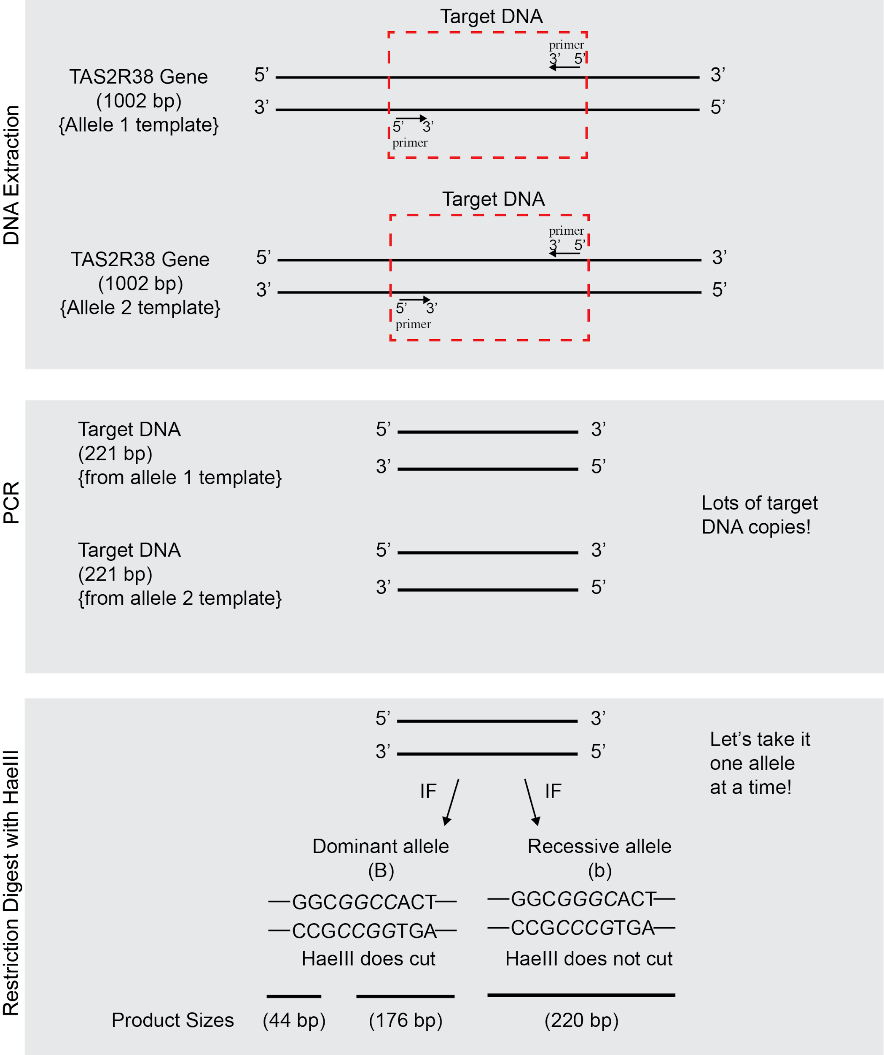
Figure 1: Overview of Laboratory Procedure

Figure 1. In this laboratory procedure, you will first isolate your own DNA from your cheek cells. We are interested in determining your genotype at the TAS2R38 locus. Therefore, we will use primers that have been designed to specifically amplify a portion of the TAS2R38 gene using PCR. Figure 3 (page 7) outlines the three key steps in PCR that allow us to make billions of copies of our target DNA. We need this many copies in order to first perform a restriction digest using HaeIII to differentiate between the dominant and recessive alleles, and then finally to visualize these resulting fragments using gel electrophoresis.
Protocol Step | Starting Material | Ending Material | Purpose
DNA Extraction | Your cheek cells | Your DNA | Obtain your DNA from the nuclei of your cheek cells
Polymerase Chain Reaction | Your DNA | >10⁶ copies of TAS2R38 target DNA (220bp) | Produce lots of copies of TAS2R38 fragment for analysis
Restriction Digest with HaeIII | 220bp-length target DNA copies | Allele-specific cut and/or uncut DNA fragments | Differentiate dominant and recessive TAS2R38 alleles using HaeIII
Gel electrophoresis | Allele-specific cut and/or uncut DNA fragments | Differently sized bands on an agarose gel | Visualize cut and/or uncut DNA fragments to determine your genotype
Table 1: Protocol Outline

This may be a useful table to reference as you are progressing through each section of the protocol to keep students on task.

Protocol

- Collecting and Isolating DNA from Your Cheek Cells

Extract your own DNA as you demonstrate how to swab from your cheek cells. Use your DNA sample to also model how to set up the PCR reaction in part II. Include your reaction in the miniPCR™ machine. Do not digest your sample with HaeIII in part III. This can be used as an undigested control sample in the gel electrophoresis in part IV.

You may want to store your students DNA samples in case of PCR failure. The supernatant from their DNA extractions can be transferred to clean 0.2mL tubes and be stored at 4°C.

You will be extracting DNA found in the nuclei of your cheek cells. These cells can be easily collected by gently swabbing the inside of your mouth with a toothpick. You will transfer your cheek cells by twirling the toothpick in a tube containing Chelex® beads. Chelex® is a chelating (binding) agent that is often used for DNA extraction. In order to isolate your DNA, we must break down the cellular and nuclear membranes. We will do this by boiling your cheek cell samples. Once these membranes are broken down, components normally in the cytoplasm have access to the DNA. These components include enzymes called DNases that break down DNA. DNases require metal co-factors for activity. The Chelex® resin will bind these metal co-factors away from the DNases, thereby inhibiting DNase activity.

- You will receive 100µL of Chelex® beads in a small, green 0.2mL tube. Clearly label the top and side of this tube with your initials using a permanent waterproof marker. You labeled your tube as: ______

The 0.2mL green tube containing the Chelex® beads may be sitting in an adapter. Please remind students to label the top and the side of smallest tube (the 0.2mL tube with the Chelex® beads) and not the adapter.

- Using the broad or flat end of a sterile toothpick, gently swab the inside of your mouth for at least 30 seconds.

This is the first make or break step in the protocol. Make sure that students scrape the inside of their cheeks thoroughly with the tip of the wide end of the toothpick.

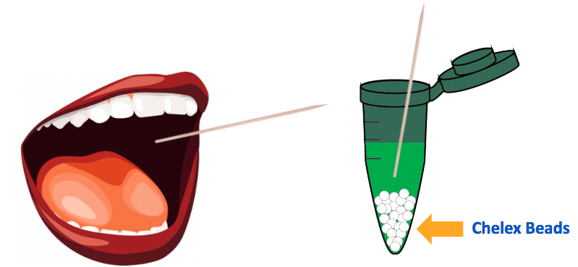
Figure 2: DNA collection and extraction procedure

- Swirl the toothpick in the tube of the Chelex® beads for at least 30 seconds to dislodge the cells and cap the tube tightly. Place used toothpick in waste container.

- Create a program on the thermocycler to hold a temperature of 99°C for 10 minutes. Name this “DNA Extraction Heat Block”.

Can either program a subsequent 4°C cooling step or remove samples immediately after these 10 minutes and place on ice.

OPTIONAL STEP: In case of PCR failure you may want to store your students’ DNA extraction samples. This will allow you to simply re-run the PCR reactions without repeating the DNA extraction. To do this, pipette supernatant (careful to avoid beads) into a clean, labeled 0.2mL tube and store in the fridge at 4°C.

- Place your 0.2mL green tube into the thermocycler. Close the lid and run “DNA Extraction Heat Block”.

- Once the DNA Extraction Heat Block protocol is finished, allow your teacher to remove your tubes from the thermocycler carefully so that the Chelex® beads at the bottom are not disturbed.

Emphasize to your students that the thermocycler is being used as a heat block and that this step is NOT the running of their PCR reactions.

- Amplifying PTC DNA by PCR

In human cells, DNA replication results in two identical copies of the entire human genome. PCR is a molecular biology lab technique that allows us to replicate a small portion of DNA that we are interested in (the “target DNA”). As you may imagine, it would be terribly difficult to find and work with only two tiny fragments of DNA isolated from one individual’s DNA. Instead, we can use PCR to locate, isolate, and make (“amplify”) millions of copies of a gene from one person. In this case, you will use PCR to isolate and amplify your own PTC gene.

A PCR reaction contains:
- Source DNA from one person (from your cheek cells!)
  - Provides a template for DNA polymerase to read
- Taq DNA polymerase
  - Bacterial enzyme that allows DNA replication at high temperatures
- Primers
  - Molecular “post-it notes” that define target DNA
    - One per each strand of DNA (forward and reverse)
  - Short DNA fragments (18-22 base pairs) that we design
  - Bind to target DNA through complementary base pairing
- dNTPs
  - Deoxynucleotide building blocks (A, T, C, G) used to make new strains of DNA
- Salts and buffers
  - Ensure correct chemical conditions for reaction
  - Includes MgCl₂ which is a co-factor required for Taq DNA polymerase activity

Steps of a PCR reaction (refer to Figure 3, page 7 for diagrams of each step)
The “chain” reaction of PCR is composed of three steps: denaturation, annealing and extension.
- Denaturation (94°C)
  - Hydrogen bonds that hold DNA together are broken, therefore DNA is separated (“denatured”) into single strands
- Annealing (64°C)
  - Primers bind to single strands of template DNA
- Extension (72°C)
  - Taq DNA polymerase creates a new strand of DNA starting at the end of each primer

These three steps constitute one synthesis cycle during which the number of copies of DNA doubles. A reaction with 35 cycles will therefore produce over a billion copies.

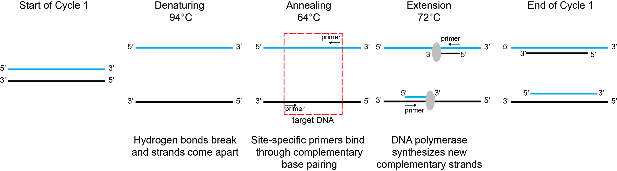
Figure 3: Steps of a PCR reaction

At the end of the first cycle of PCR you will have 4 strands (2 original template strands, 2 newly synthesized strands). Draw out the steps that occur during the second cycle below. How many strands will you have at the end of cycle 2?
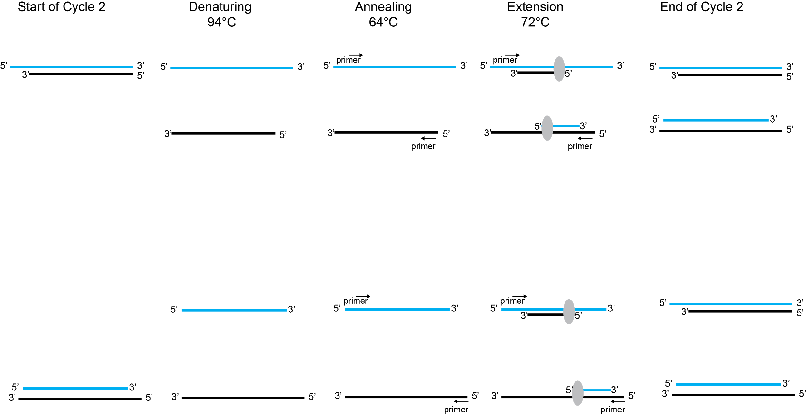

Stop and Think
At which cycle of the PCR reaction will you have amplified a fragment of just the target sequence? 3

In order to ensure DNA sample is added, have your students pipette to the side of the 0.2mL clear tube that contains the Master Mix. They should see a small droplet of their DNA on the side of the tube. Once they confirm this, have them close their tubes and tap them down to make the DNA droplet pool at the bottom with the Master Mix.

If you have a centrifuge, we recommend having your student pulse down their samples before starting the PCR reaction. If you are planning to centrifuge your samples, make sure the 0.2mL clear PCR tubes are in the appropriate adapters before placing them in the centrifuge.

- Carefully pipette 2.5µL of the supernatant, which contains your DNA, to the 0.2mL clear PCR tube that already contains the TAS2R38 Primer Master Mix. Label the tube with an asterisk* and your initials. This tube now contains everything you need in order to run a successful PCR reaction (template DNA, TAS2R38 primers, and a standard master mix). Centrifuge your sample for 30 seconds in the adapters to pool reagents and store it on ice until ready to begin the reaction.

The PCR Master Mix includes:
· OneTaq® DNA Polymerase
· TAS2R38 specific primers
· dNTPs (A, T, C, G)
· Salts (Tris-HCl, KCl, NH₄Cl, MgCl₂) pH 8.9

Remind students of the PCR analogy detailed at the end of this teacher’s guide and in the slides. The purpose of salts is for optimal OneTaq® DNA polymerase efficiency.

- Program your thermocycler by creating a new PCR protocol, following the temperature and time specifications below. Name this protocol “PTC PCR Program”.

 | Step | Temperature | Time
 | Initial Denaturation | 94°C | 300 seconds
 | Denaturation | 94°C | 30 seconds
Repeat 35 times | Annealing | 64°C | 30 seconds
 | Extension | 72°C | 30 seconds
 | Final Extension | 72°C | 60 seconds
Table 2: PCR Cycle details

- When the program is finished, allow your teacher to remove your labeled tube from the thermocycler as it will be hot.

Can either program a subsequent 4°C cooling step or remove samples immediately after place the 0.2mL clear tubes on ice.

OPTIONAL STOPPING POINT: Once PCR reactions have finished, can store PCR reactions in fridge at 4°C until ready to proceed or leave them in the thermocycler at 4°C (not recommended for longer than overnight due to wear on machine itself).

- Store the rest of your samples on ice or at 4°C until ready to begin the next part.

- Restriction digest of PCR products with HaeIII

The HaeIII enzyme will come to you diluted to the working concentration of 5U/mL. Aliquot 12µL of this enzyme into 1.5mL microcentrifuge tubes for groups of 4. Students will use 2µL each, totaling 8µL. The remaining 4µL are extra in case of pipetting errors. Place these in student ice buckets or cups.

You have now amplified a portion of the TAS2R38 gene. PCR amplification will result in a DNA fragment 220 base pairs (bp) long. Recall that the TAS2R38 gene has a dominant and a recessive version, and that the two alleles can be differentiated by a single-nucleotide polymorphism (SNP). In order to differentiate between a dominant and a recessive allele, we will perform a restriction digest on the PCR products using the HaeIII restriction enzyme. Restriction enzymes cut at specific DNA sequences termed recognition sequences. HaeIII recognizes a 5’ GGCC 3’ DNA sequence (refer to Figure 1, page 2). The dominant allele contains the 5’ GGCC 3’ recognition sequence and therefore will be cut by HaeIII. Note this sequence occurs on both strands when read from the 5’ to 3’ direction. This results in two fragments post restriction digest: 176 bp and 44 bp.The recessive allele lacks this recognition sequence and therefore will not be cut by HaeIII. This results in a 220 bp uncut fragment post restriction digest.

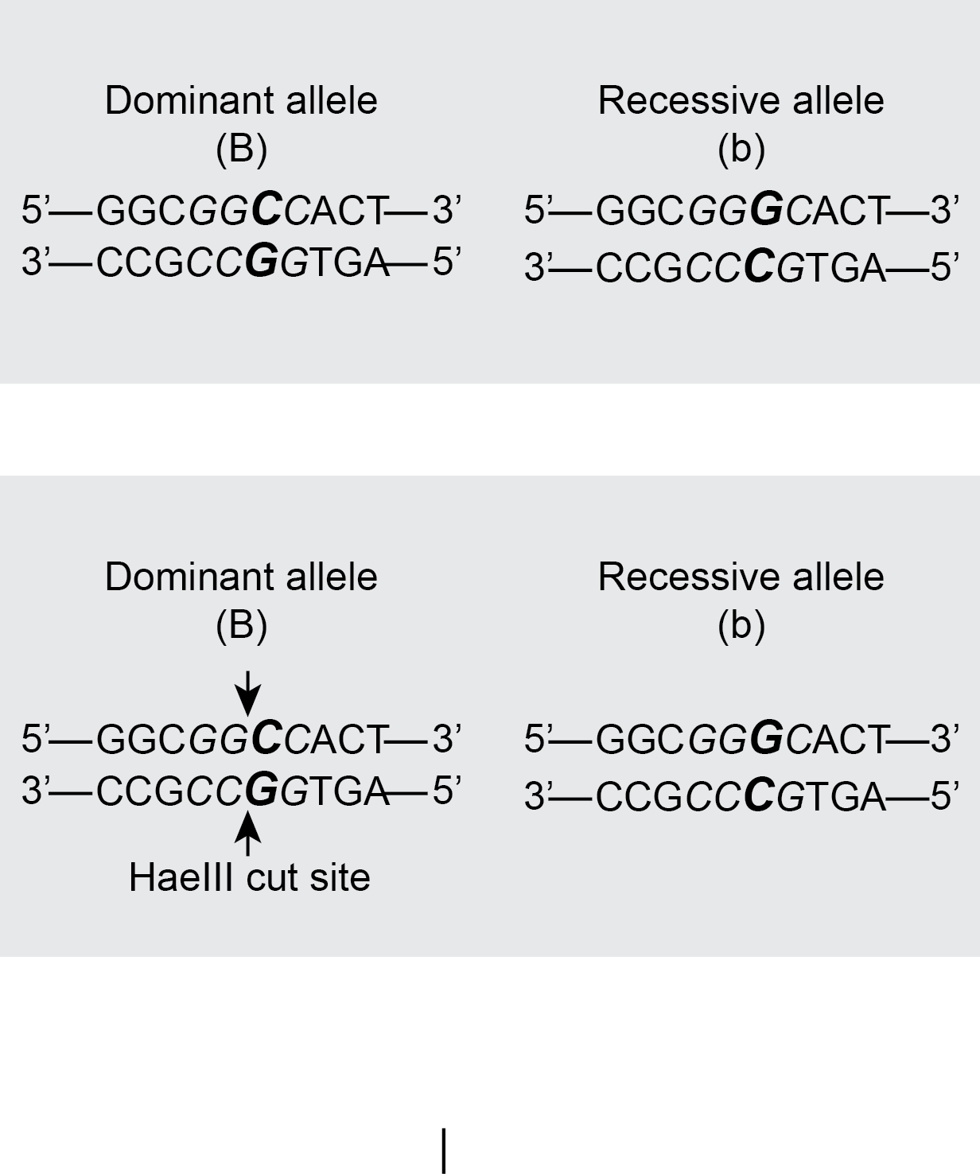

Based on this information, fill out Table 3 below and compare with your classmates.

Genotype | Allele 1:  cut, uncut? | Allele 2:  cut, uncut? | DNA fragment sizes
BB | Cut | Cut | 176bp, 44bp
Bb | Cut | Uncut | 176bp, 44bp, 220bp
bb | Uncut | Uncut | 220bp
Table 3: Results of Restriction digest with HaeIII

- Using a p10 or p20 micropipette, add 2µL of HaeIII restriction enzyme from the pink tube your teacher handed out into your PCR sample. You will be digesting your entire sample.

As you will be demonstrating the steps for your students, we suggest that you create your own undigested control as well. Make sure to store your own PCR reaction (and not digest it) in order to have an undigested control sample for the gel. You will need to do multiple samples for the PCR reaction in order to have a
control DNA sample for each gel.

We have tested that 2uL keeps HaeIII in sufficient excess to DNA to ensure full
digestion of PCR products.

- Gently pipette up and down 3-4 times to ensure that the enzyme mixes with your sample.

- Centrifuge the PCR tubes for 30 seconds in the adapters to pool reagents.

If centrifuging, make sure that clear PCR tubes are placed in adapters.
Alternatively, students can tap tubes down to pool reagents at the bottom.

- Create a program on the thermocycler to hold a temperature of 37°C for 5 minutes. Name this “PTC Digest”.

Can optionally program a subsequent heat-inactivation step at 80°C for 20
minutes. This will inactivate the enzyme and definitively prevent further digestion.

OPTIONAL STOPPING POINT: Can store PTC Digest samples in fridge at 4°C
until ready to run gel electrophoresis.

- Place your labeled clear tube back into the thermocycler for digestion. Close the lid run “PTC Digest”.

- Gel Electrophoresis

- Gel loading
  - Prepare gels before part IV. Make sure you add the appropriate amount of SyberSafe® to your molten agarose/buffer mix. For example, if your gel tray takes 30mL of this molten agarose/buffer mix, you must add 3µL of SyberSafe®. Remember to mix thoroughly before pouring into your gel tray. Cover or keep your gels out of light while they dry.
  - You will need one lane per student sample, one lane for undigested control sample, and one lane for ladder in each gel.
    - It is up to you whether students sign themselves up for a lane or you pre-assign each student and keep track of the list. We have included a sample sign-up template on page 23 of this manual.
  - Before students load their samples, ensure that you have loaded 10µL of 100bp ladder into the first lane and 20µL of your undigested control in the second lane.

After the restriction digest with HaeIII, the resulting DNA fragments will be separated on an agarose gel using gel electrophoresis.
Gel electrophoresis is a technique that uses an electrical current to separate biomolecules based on size and charge. Since all DNA is negatively charged (due to the phosphate groups in the sugar-phosphate backbone), gel electrophoresis will separate DNA fragments based on size. DNA is loaded into the wells of the agarose gel at the negative end (anode). Electricity is applied and as electrical current passes through the gel, the negatively charged DNA fragments move towards the positive end (cathode). An agarose gel is a porous matrix. Therefore, smaller DNA fragments will be able to move through the pores easier and travel faster. Larger DNA fragments will have more difficulty moving through the gel and therefore travel slower. As the sample progresses through the gel, the fragments sort into distinct bands based on their size.
Since we amplified billion of copies of our TAS2R28 gene in the PCR reaction, we should have sufficient DNA to visualize. The bands of DNA can be visualized by illuminating the gel with the UV light. The gels have been prepared with SyberSafe®, a dye that attaches to DNA and fluoresces under UV light.
- Add 2µL of colored loading dye to your PCR sample before loading it on the gel.

It is possible that your master mix already included a green loading dye. If it did, you may still want to add additional loading dye to ensure sample settles in well.

- Your teacher will direct you to the gel sign up sheet. Sign up for a specific lane for which you will load your sample. Your teacher will load the 100bp ladder and the undigested control into the specific lanes that are noted on the signup sheet.

On page 23, you will find an example gel sign up sheet. You may want students to signup in whichever lane they’d like, or you can pre-assign students to specific lanes to avoid confusion. As the teacher, you are responsible for loading the 100bp ladder and the undigested control. Use these samples to model for students how to load into a gel.

- Load 20µL of your PCR sample into your assigned well. Gently depress the pipette button to the first stop to slowly expel the sample without introducing bubbles.

Consult the gel system user manual (or your ABE technician) to find out what the
volume range is for the comb you are using. For example, many combs have two size options for the wells they create. You do not want to overflow the well with too much sample.

- Run the gel as instructed (voltage and time). Depending upon your gel system, the gel will end on its own or you will need to stop the gel and notify your teacher that you have finished.

There are many different types of gel electrophoresis chambers available for teachers to use. It is important to remember that certain lab protocol specifications can change, depending on your gel electrophoresis system. These may include:
  - Volume of sample loaded into a gel (dependent on tray and comb size)
  - Volume of buffer loaded into the chamber (dependent on chamber size)
  - Voltage (some gel boxes give users free range to choose a voltage, others have three pre set voltages to choose from, and finally others do not let the user change the voltage)
  - Time (dependent on the voltage of the machine)

If you are using the Fotodyne or Thermal Fisher gel system, we suggest you run the gel for 30 minutes at 120-130 volts.

We suggest follow their recommendations making sure to not melt the gel (which will happen at too high of voltage) and watching the loading dye to ensure that samples do not run off the gel (which will happen if run at too high of voltage or for too much time).

- In Table 3 (page 10) you deduced for each genotype whether the alleles present would be cut or uncut and you further noted the fragment sizes. Using this information, for each genotype draw where the resulting fragments would be predicted to run on the gel and draw the bands on Figure 4 (page 13).

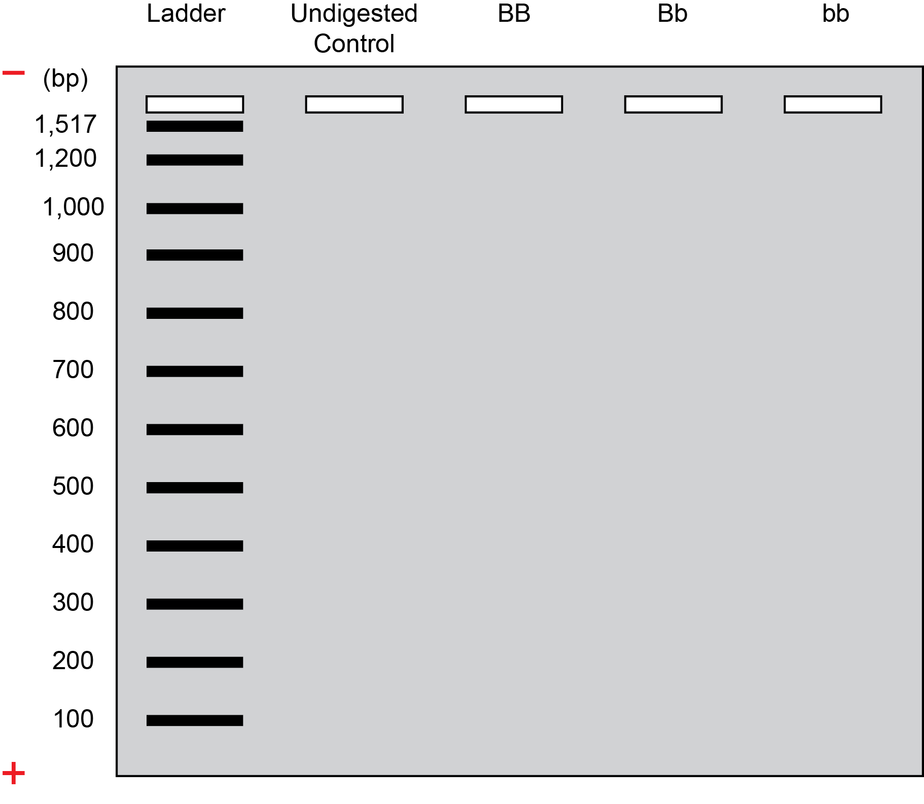
Figure 4: Predicted Gel Results for each tasting genotype

- After your gel has finished running, you will visualize your bands. Draw your actual results in Figure 5 (page 13) and then compare with classmates for the other corresponding genotypes to complete the figure.

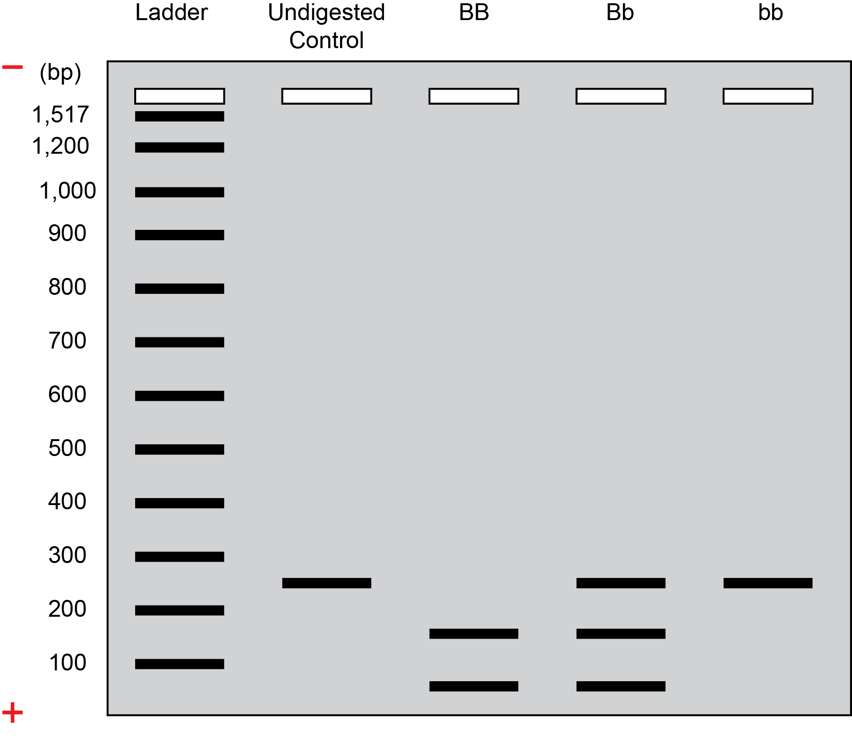
Figure 5: Actual Gel Results for each tasting genotype
Teacher Resource: Optional Pre-Laboratory Vocab Review

Name: ______________________
Class/Period: ________________

In the laboratory, you will be extracting your DNA from your cheeks cells and analyzing a specific portion of your genome that is related to perception of taste. Before doing this lab, it will be helpful to refresh the vocabulary below.

Phenotype:

Genotype:

DNA:

Allele:

Dominant:

Recessive:

Homozygous:

Heterozygous:

Teacher Resource: What is Chelex®?
- Chelex is a chelating agent from Bio-Rad that binds transition metal ions such as Mg²⁺
- Why is it needed? What happens when cells are lysed?
  - When lysing the cells, DNA is released from the nucleus and mitochondria and mixed with the contents of the cytoplasm
  - The cytoplasm contains DNases, which degrade DNA. While we do boil at 99°C for 10 minutes, some DNases may still have residual activity.
  - These DNases require Mg²⁺ for activity
  - By removing Mg²⁺ using Chelex®, the DNases are prevented from degrading the DNA. This ensures the DNA is kept intact for the subsequent PCR reaction.

Teacher Resource: PCR
- What is PCR?
Polymerase chain reaction (PCR) is used to amplify a specific region of DNA.
  - Why is it necessary to amplify DNA?
    - When DNA is isolated all of the DNA is isolated, not just the region of interest. PCR allows us to 1) make sufficient copies of DNA to analyze via gel electrophoresis and 2) copy just our region of interest.

  - What happens during the PCR reaction?
    - Students may know that PCR is about copying DNA, point out this is the extension step.
    - You could then ask them what is needed to allow the DNA polymerase to start synthesizing DNA (Answer: Primers, which anneal to the target DNA during the annealing step and dNTPs, which are the building blocks for new strands).
    - You could then ask them what has to happen for primers to anneal to the DNA (Answer: Separation of DNA into single strands, which occurs during the denaturation step due to breakage of hydrogen bonds).

  - What does a thermocycler do and how it useful for PCR?
    - A thermocycler will cycle through pre-set temperatures for pre-set amounts of time as needed, for as many cycles as it is programmed for (the amount of DNA doubles with each cycle).

- 94°C: Denaturation (double-stranded DNA denatures into single strands)
- 64°C: Annealing (primers anneal to single-stranded DNA)
- 72 °C: Extension (Taq polymerase synthesizes new DNA strands complementary to the existing strands using the primers as starting points)

    - Taq is a specific polymerase that has been isolated from a thermophilic (high temperature-loving) organism and thus can withstand high temperatures

    - The discovery of this enzyme was the breakthrough in PCR technology, because it meant a thermocycler could be used and scientists did not have to add new enzyme for each PCR cycle

- How do primers work?
  - Two primers (one of each strand) will together act like bookmarks to determine which region of DNA will be amplified (the “target DNA”). They themselves are short pieces of DNA that anneal to the beginning and end of the target DNA through complementary base pairing to the forward and reverse strands, respectively.

- Guidelines to creating your own PCR-Book Analogy
  - Introducing PCR through an analogy can help students understand the overall concept of PCR, as well as the individual components of a PCR reaction.
  - PCR allows users to generate lots (over one billion) of copies of a specific target area of DNA. It’s quite similar to making copies of a specific quote in any book!
  - Let’s take a look at the components necessary to make copies of a specific quote in a book
    - The book
    - The quote that you are interested in copying
    - Post-its showing where the quote starts and where it stops
    - Pen to write out the quote
    - Ink: You need ink in order for your pen to work
    - ABCs: You need the letters of the alphabet
  - Let’s take a look at the components of a successful PCR reaction
    - Template DNA
    - Specific region of DNA (“target DNA”) you want to copy
    - Specific primers
    - DNA polymerase
    - Salts
    - dNTPs
  - How do these items link together?
    - See our table below
  - How should you introduce this analogy to your students?
    - Depending on the level of your students, we recommend that you decide which components to introduce first: either the PCR components or the book analogy components. You can then ask them to deduce how the components are connected.
    - Where to start?
      - You may want to write the book-analogy items on the board first (book, Post-its, quote, etcl).
      - Students are then asked what biological components correlate to these words.
      - It may work best by writing the simple words on the board first rather than writing template DNA, primers, polymerase, dNTPs, gene or DNA of interest, as your students may not be familiar with these terms
      - If introducing the book analogy components, students can then utilize the PCR components table in the student manual to begin making connections.

Book Analogy | PCR | Explanation
Book | Template DNA | Extracted from our cheek cells, template DNA is our entire genome, much like the book is the entire story.
Quote | Specific region of DNA | We are interested in analyzing only a small portion of our genome (“target DNA”), much like specific quotes from a book can be analyzed.
Post-its | Specific Primers | We use primers to designate the region we’re interested in, much like post-its can be used to mark where a quote ends and begins to quickly find it in a book.
Pen | DNA Polymerase | The DNA polymerase synthesizes or makes new copies of this target region, much like a pen is used to copy down a quote.
Ink | Salts | Salts are used to create the unique and optimal environment for the DNA polymerase to work, much like the ink in a pen. If the pen has no ink, no copying will take place.
ABCs | dNTPs | dNTPs, the building blocks of DNA, are required by DNA polymerase in order to synthesize new strands, much like a pen will depend on letters of the alphabet to put together the words of the quote.

Teacher Resource: Template Sign-Up Sheet for Gel Loading
Adjust the number of lanes to reflect the gels that you will be using in class. You may want students to signup in whichever lane they’d like, or you can pre-assign students to specific lanes to avoid confusion. As the teacher, you are responsible for loading the 100bp ladder and the undigested control. Use these samples as demos to remind students how to load into a gel.
Gel Loading Scheme for PTC PCR

Class Period: ____________
Gel Number: ____________

Lane | 1 | 2 | 3 | 4 | 5 | 6 | 7 | 8 | 9 | 10
Initials | LAD | UCS

Label your the initials on your tube in the diagram above and write your name in the sign-up below.

Lane 1: 100bp DNA Ladder
Lane 2: Undigested Control Sample
Lane 3: ____________________
Lane 4: ____________________
Lane 5: ____________________
Lane 6: ____________________
Lane 7: ____________________
Lane 8: ____________________
Lane 9: ____________________
Lane 10: ___________________

