Colony PCR Laboratory
Colony PCR uses what is referred to as a “Master Mix,” and New England Biolabs provides ABE programs with OneTaq® 2X Master Mix with Standard Buffer. This includes the dNTPs, magnesium, and Taq polymerase all in one tube. All you have to do is add the appropriate volume of forward and reverse primers, as well as your DNA (in this case, your bacterial colony).

How to Use New England Biolabs OneTaq® 2X Master Mix with Standard Buffer
Now, you will have to combine this working concentration primer with the New England Biolabs OneTaq® 2X Master Mix with Standard Buffer using the following recipe:
  - For every PCR reaction that will be run, add together:
    - 10 µL of the primer mix: [5µL F primer (1 nm/µL) and 5 µL of R primer (1 nm/µL)]
    - 13 µL of NEB OneTaq master mix
Tips:
  - Teachers will add primer to the Master Mix
  - Add the primers to a PCR master mix immediately before use so that students only need to add their DNA to assemble their reactions.
  - If you have 12 student groups running four samples each for the ABE Colony PCR lab, you will need to run a total of 48 samples. We suggest that when you make the primer + TAq solution, you increase the sample number for extra volume.
    - For example: If you have 48 samples, add at least four samples to account for errors, so use 54 to calculate volumes.
      - 54 samples x 10 µL/sample for primer = 540 µL of ABE Colony Primer
      - 54 samples x 13 µL/sample = 702 µL of NEB OneTaq quick load (Labeled TAQ). Note this Taq solution contains the buffers and nucleotides as well as the Taq enzyme.
    - Each student group will need at least 92 µL of this primer + TAQ mix ( labeled PCR)to run four PCR. Students will aliquot 23 µL to each tube (4 tubes @ 23 µL=92 µL)
    - Aliquot 100µL of the Master Mix per group to allow for some wiggle room.
  - Be certain to thaw and re-suspend reagents completely before aliquoting. Mix well and keep on (wet) ice. Students will add ~2 µL of their DNA (colony from plate) or 2 µL of control plasmid to the tube with the master mix. and set it up in the PCR machine.

One or Two Days before Colony PCR Lab
Programming the Thermocycler
The chart below explains how to program the thermocycler.
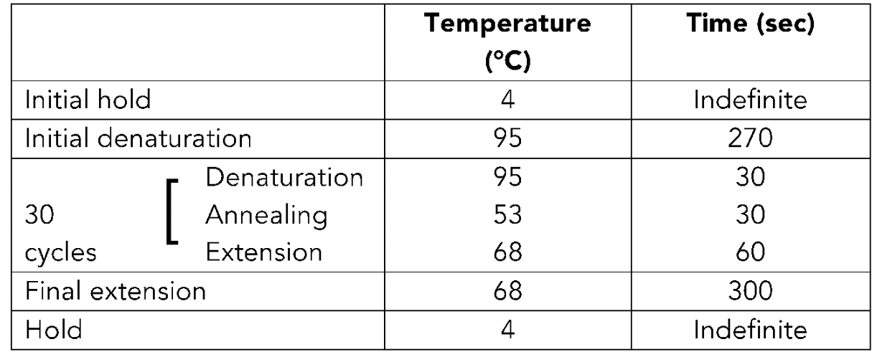
NOTE: Not all Thermocycler models will allow for a 4˚C hold.
Day of Colony PCR (Prior to Part I PCR class)
Preparing the Master Mix
Once the master mix is thawed, it’s very important to keep the mixture in wet ice. If allowed to sit at room temperature, it’s possible to produce not only primer dimers but additional unintended amplification products.
Pipet the PCR master mix + Taq up and down several times to mix it thoroughly, then aliquot 100 µL into each microfuge tube marked “PCR.” Store at 4°C. You can prepare this mixture the morning of the lab, store it at 4˚C, and use throughout the day. Do not store overnight at 4˚C or you risk the quality of the PCR reaction.

Day of Gel Electrophoresis (Prior to Part II Gel Electrophoresis class)
Prepare 6 gels. (The video Making an Agarose Gel on the ABE program website walks you through the process of making an agarose gel and casting it as described below.) Refer to Instruction sheet in Resource Binder. We also have a gel preparation video on the RI Amgen Biotech Experience webpage. Remember to add SYBR Safe to the molten agarose before casting the gel. Gels can be made the day before the electrophoresis if needed.

PDI Laboratory Prep
Prepare the following materials:
- 6 gels with SyberSafe® or GelGreen® using 10-well comb
- PCR master mix with primers and Taq polymerase (store at -20˚C)
- 12–14 tubes with 3 µL pARA-R labeled “+” (store at 4˚C)
- 12–14 tubes with 3 µL pARA labeled “-” (store at 4˚C)
- Plastic container full of water and crushed ice
- Fine-tip marking pen
- 12- P-20 pipettes or P10
- P-20 pipette tips or P10 tips
- 6 Cups with disinfectant for tip disposal
- Storage container for prepared gels
Laboratory Setup
Supplies needed for a class of 24 students (12 groups of 2):
PART A – PCR REACTION
- 12- P-20 micropipettes with tips
- 12P-10 micropipettes with tips
- 12–cups (or ice buckets)
- 12- fine-tip permanent markers
- Ice (crushed preferable)
- Deionized or distilled Water
- 3 or more LB/amp/ARA plates with transformed colonies
- 12–tubes of PCR Master Mix + Taq (labeled “PCR”)
- 12- 0.025 ng/µL pARA-R plasmid “+” control tubes (stored at 4˚C)
- 12– 0.025ng/µL pARA plasmid “-“ control tubes (stored at 4˚C
- PCR tube strips and 48 caps (or small PCR tubes) – 4 tubes/student or group
- Waste containers (for used tips and microfuge tubes)
- Thermocycler
- Microcentrifuge with PCR tubes adapters

PART B – GEL ELECTROPHORESIS
- 12- P-20 micropipettes
- 6 prepared gels (using 10-well comb )
- 6 electrophoresis chambers and power supplies
- 1X sodium borate buffer
- 12 microfuge tubes (1.5-mL) with DNA Ladder (labeled “M”)
- 24 copies of DNA Ladder Diagram (RM E)
- Transilluminator

Tips
- Colony PCR Lab Prep
- If necessary, the master mix and primers can be mixed and frozen up to 3 weeks prior to the lab with good amplification results. However, this should only be done for reliable teachers as the mixed reagents will be wasted if not used.
- Picking a colony
- Students often want to pick up a large amount of cells when picking up a colony off the plate; only a tiny bit is necessary (turbidity/too many cells will negatively affect the PCR amplification).
- The student picking the colony should be the same student holding the plate.
- Remind students to collect cells only, and NOT to pick up the agar!
- Model for students how to use a precise colony-picking motion rather than a “digging” motion.
- Try using just the pipette tip to pick up the cells; it’s much easier than holding an entire pipette.
- Satellite Colonies
- Some sites have had issues with satellite colonies forming on their plates during Getting a Recombinant Plasmid into Bacteria (Lab 5/5A/5B).
- To avoid satellite colonies forming, move plates from incubator to the refrigerator right around the 24-hour mark.
- Plates without satellite colonies allow students to isolate a colony much easier.
  - Trouble Shooting
- Always check that the thermocycler is set to the correct program before running students' samples. If you use miniPCR machines, you should check student setups for the correct protocol as well.

