Grow Bacteria for Protein Purification
To be arranged with RI program site.
A couple days before Laboratory 6, prepare a suspension culture of bacteria that have been transformed with the pARA-R (provided in your kit). (typically marked with a T or” transf cells”)
Materials:
- 1000ul Pipette
- Transformed cells (provided in kit)
- Sterile flask containing LB/amp broth
- Shaker
- 3 tubes of sterile arabinose
- Start your lab 6 culture 4-5 days BEFORE you will need it. It can be stored in the refrigerator until the lab.
- Inoculate the LB amp broth with vial of transformed cells when you get to school in the morning.
- After several hours of shaking (This can be anywhere from 2-3 hours) and when the broth starts to turn cloudy but not TOO cloudy), add the arabinose (1 full tube).
- Continue shaking overnight. We have enclosed an additional tube of Arabinose; you can add before you go home for the night.
- If your culture is not bright pink the next morning, add the other tube of arabinose and let it continue to shake through the next day. pare the suspension culture:
- Optimal
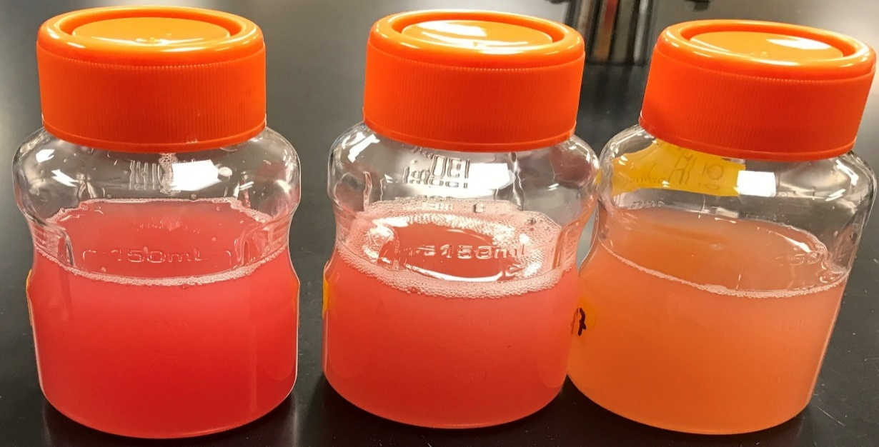
Ok to use
Not optimal
Optimal

